**PIZZA SALES SQL QUERIES**

**KPI**

1. Total Revenue:

SELECT SUM(total_price) AS Total_Revenue

FROM pizza_sales;

1. Average Order Value:

SELECT SUM(total_price)/COUNT (DISTINCT(order_id)) AS Average_Order_Value

FROM pizza_sales;

1. Total Orders:

SELECT COUNT (DISTINCT(order_id)) AS Total_Orders

FROM pizza_sales;

1. Average Pizza Per Order

SELECT CAST(SUM(quantity) AS DECIMAL(10,2)) / CAST(COUNT(DISTINCT order_id)AS DECIMAL(10,2)) AS Average_Pizzas_Per_Order

FROM pizza_sales;

**CHARTS**

1. **Daily trend**

SELECT DATENAME(DW, order_date) as order_day, COUNT(DISTINCT order_id) AS Total_orders

from pizza_sales

GROUP BY DATENAME(DW, order_date) ,

1. **Monthly Trend**

SELECT DATENAME(MONTH, order_date) as Month_Name, COUNT(DISTINCT order_id) AS Total_orders

from pizza_sales

GROUP BY DATENAME(MONTH, order_date) ;

1. **Percentage of Sales by Pizza Category**

SELECT pizza_category,

SUM(total_price) AS category_sales,

SUM(total_price) * 100/ (SELECT SUM(total_price) FROM pizza_sales) AS SalesPercentage

FROM pizza_sales

GROUP BY pizza_category

ORDER BY SalesPercentage DESC;

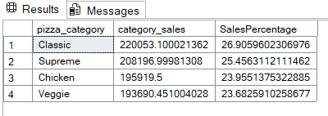

1. **TOP 5 BEST SELLERS BY REVENUE**

SELECT TOP 5

pizza_name,

ROUND(SUM(total_price), 0) AS Total_Revenue

FROM pizza_sales

GROUP BY pizza_name

ORDER BY Total_Revenue DESC;

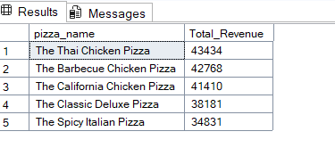

1. **TOP 5 BEST SELLER BY QUANTITY**

SELECT TOP 5

pizza_name,

ROUND(SUM(quantity), 0) AS Total_Quantity

FROM pizza_sales

GROUP BY pizza_name

ORDER BY Total_Quantity DESC;

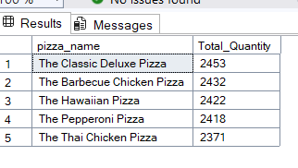

1. **TOP 5 BEST SELLER BY TOTAL ORDERS**

SELECT TOP 5

pizza_name,

COUNT(order_id) AS Total_Orders

FROM pizza_sales

GROUP BY pizza_name

ORDER BY Total_Orders DESC;

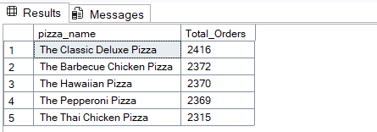

1. **BOTTOM 5 WORST SELLER BY TOTAL ORDERS**

SELECT TOP 5

pizza_name,

COUNT(order_id) AS Total_Orders

FROM pizza_sales

GROUP BY pizza_name

ORDER BY Total_Orders asc;

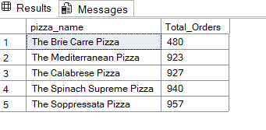

1. **BOTTOM 5 BY REVENUE**

SELECT TOP 5

pizza_name,

ROUND(SUM(total_price), 0) AS Total_Revenue

FROM pizza_sales

GROUP BY pizza_name

ORDER BY Total_Revenue ASC;

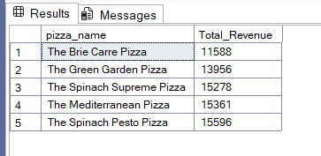

1. **BOTTOM 5 BY TOTAL QUANTITY**

SELECT TOP 5

pizza_name,

ROUND(SUM(quantity), 0) AS Total_Quantity

FROM pizza_sales

GROUP BY pizza_name

ORDER BY Total_Quantity ASC;

